PROBLEM STATEMENT

Implementation of a calculator using a client-server network, along with a remote desktop. The query is entered in the client (such as 2+2) and is sent to the server for calculation. The result is then displayed on a remote desktop.

This concept can be used in classrooms where students enter the required equation on the client-side calculator, and the result is printed on a remote desktop - which could be the teacher’s system or the classroom television.

The result printed on the remote screen also has the name of the client who requested for that result.

TOPOLOGY
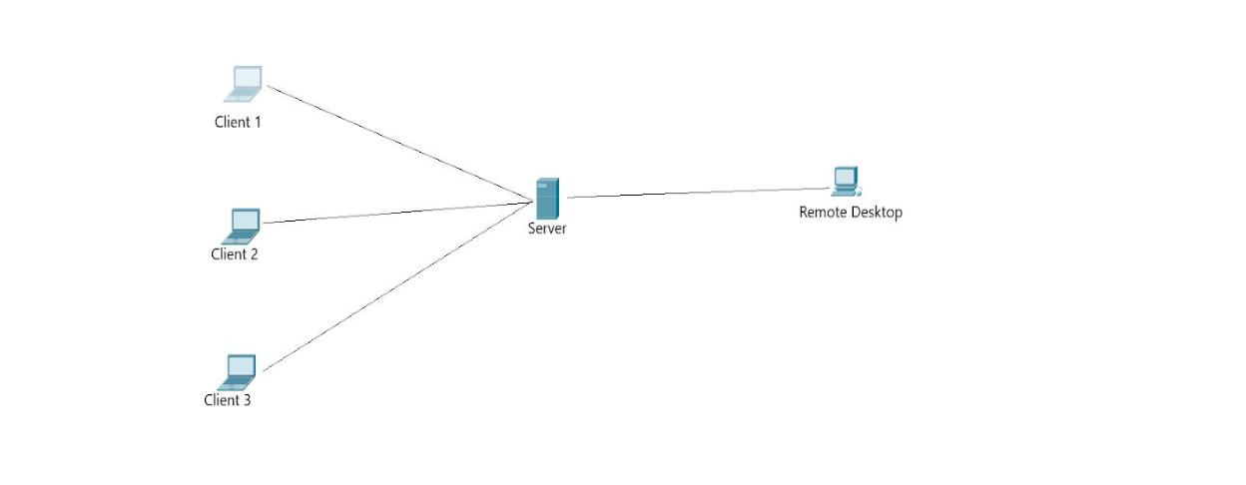

MODULES

We developed 3 main modules, namely, the ​client​module, ​server​module, and the ​remote desktop​module.
We integrated ​tkinter​,for the calculator UI, into the program.

The client is where the user enters the arithmetic expression that he wants to solve. This equation

is sent to the server module.

There can be multiple clients.

At the server, the result of the expression is calculated, and the result is sent to the remote desktop module and it is displayed there.

NETWORKS CONCEPTS USED

We have implemented the transport layer UDP protocol using sockets.

We have also created a remote desktop for which at least 2 connections are being maintained simultaneously at the server.

NEW CONCEPTS LEARNT

- Creation and implementation of a Remote Desktop using UDP to emulate RDP.

- Maintaining atleast 2 connections open at once at the server.

INPUT
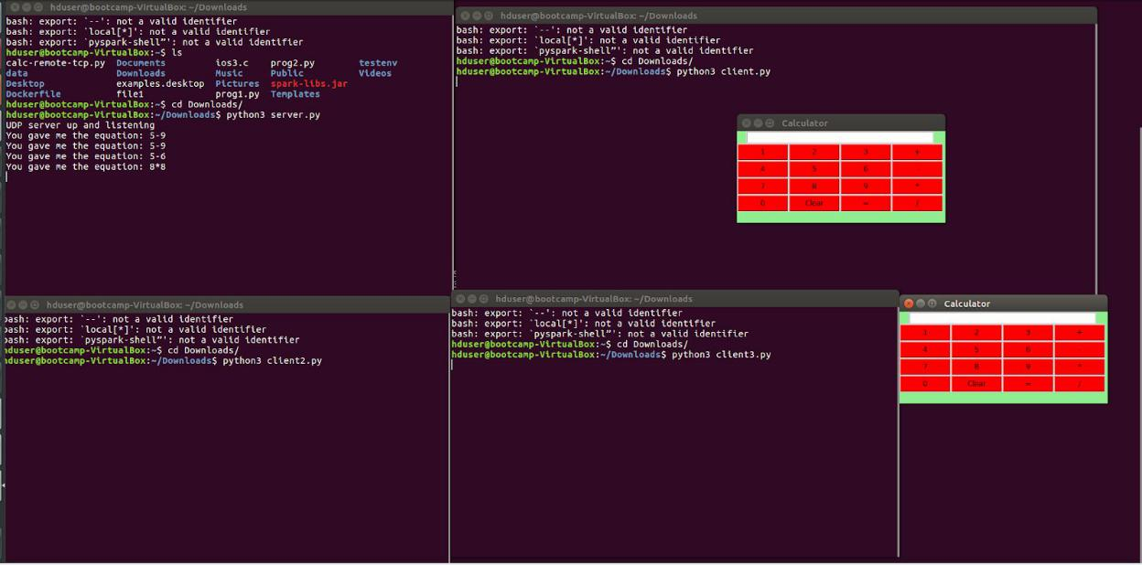

OUTPUT
